UI POLICY
What
A Catalog UI Policy is configured for the Network Request catalog item to dynamically control the visibility of fields based on the user's selections.
In this implementation, when the user selects:
Type of Connection = Existing
the Enter your Existing ID field becomes visible.
This provides a dynamic form experience where users see only the information relevant to their selected request type.
Why
Displaying all fields at once can make a catalog form confusing and unnecessarily lengthy.
The UI Policy improves the request form by:
- Showing relevant fields only when required.
- Reducing unnecessary user input.
- Improving form usability.
- Preventing irrelevant information from being entered.
- Supporting conditional data collection.
- Making the request process more intuitive.

Activity 1 – Create Catalog UI Policy
What
Create a Catalog UI Policy for the Network Request catalog item.
How
- Navigate to the Network Request catalog item.
- Open the catalog item's related lists.
- Locate Catalog UI Policies.
- Click New.
- Configure the UI Policy.
Use the following configuration:
Field | Value
Applies to | Catalog Item
Catalog item | Network Request
Short description | Display Existing ID for Existing Connection
Condition | Type of Connection is Existing
- Review the condition.
- Click Submit/Save.
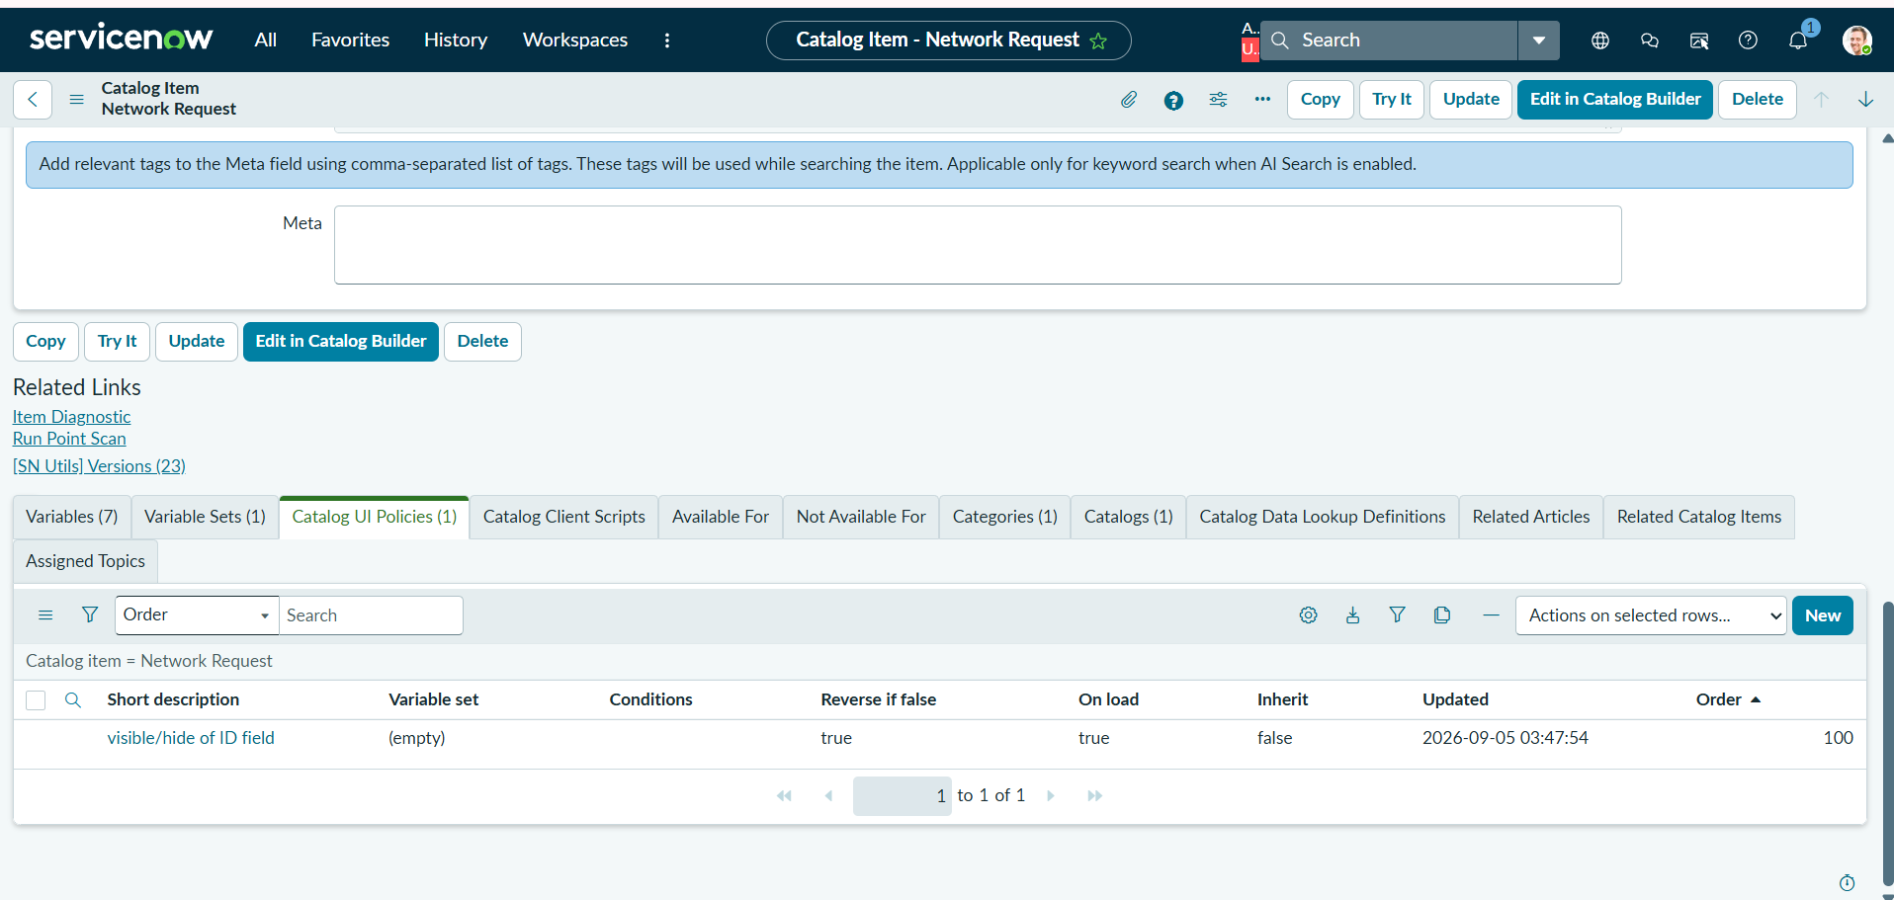Activity 2 – Configure UI Policy Action
What
Configure a Catalog UI Policy Action to determine which field is displayed when the UI Policy condition evaluates to true.
How
After saving the UI Policy:
- Open the newly created UI Policy.
- Locate the Catalog UI Policy Actions related list.
- Click New.
- Select the variable:
Enter your Existing ID
- Set:
Visible = True
- Configure other properties according to the requirement.
- Save the UI Policy Action.
Configuration
Property | Value
Variable | Enter your Existing ID
Visible | True
Mandatory | As required
Disabled | As required
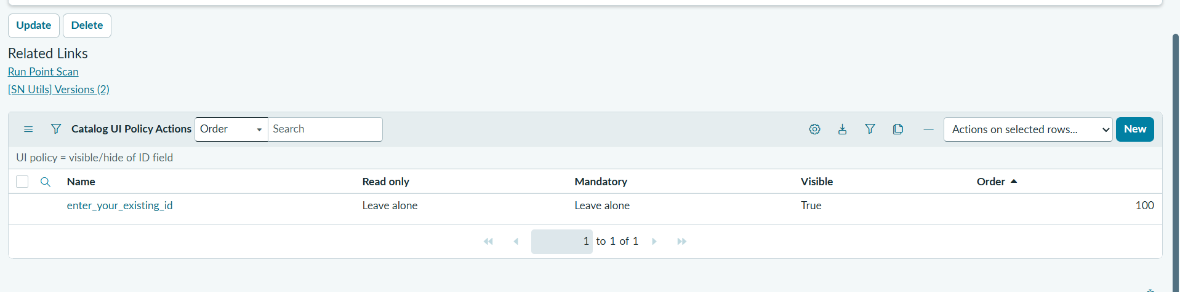

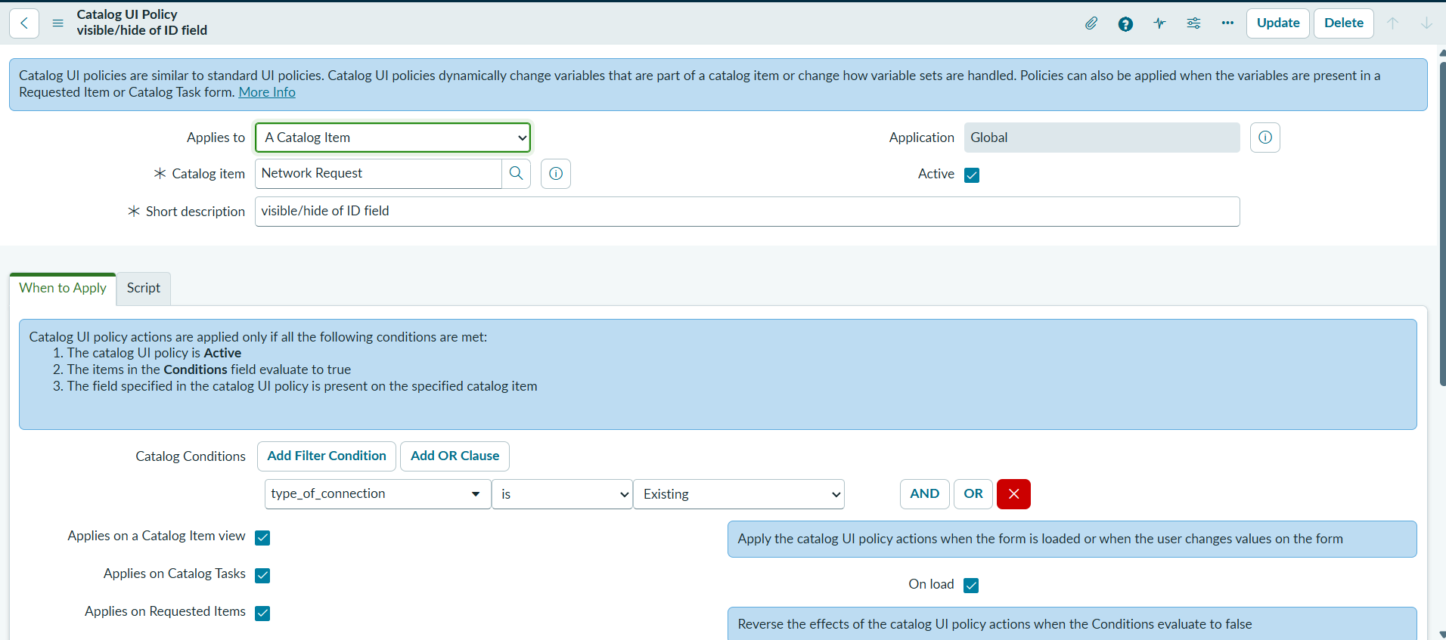
Activity 3 – Test the Conditional Behavior
What
Test the Network Request catalog form to verify that the UI Policy dynamically displays the Existing ID field.
How
- Open the Network Request catalog item from the Service Portal.
- Locate Type of Connection.
- Select:
Existing
- Observe the form.
The Enter your Existing ID field should become visible.

Validation
Perform both test scenarios:
Test Case | Selection | Expected Result
TC-UI-01 | Type of Connection = New | Existing ID field remains hidden
TC-UI-02 | Type of Connection = Existing | Existing ID field becomes visible
If the policy is configured correctly, the behavior should be:
New → Existing ID hidden
Existing → Existing ID visible

Outcome
The Catalog UI Policy introduces conditional behavior into the Network Request form.
When a user selects Existing as the connection type, ServiceNow automatically displays the Enter your Existing ID field. When another connection type is selected, the field remains hidden.
This results in a cleaner, more intuitive, and context-aware request form while ensuring that additional information is collected only when it is relevant.

